HOMEWORK 8

Section 8.1:

4) 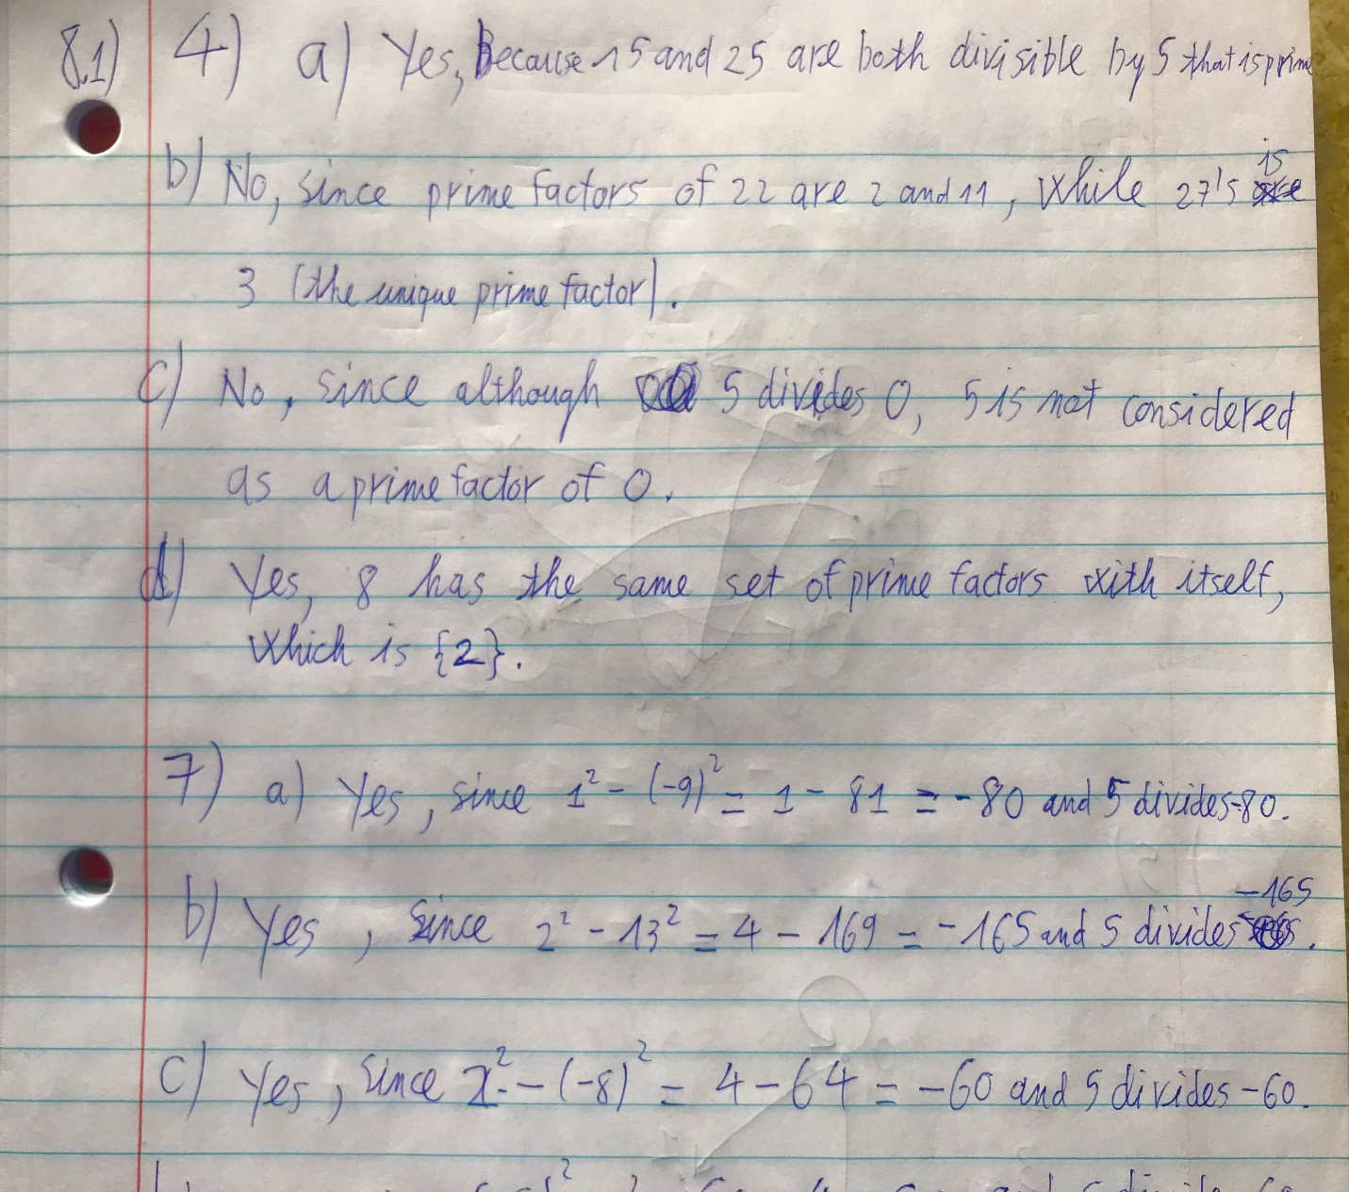

7) 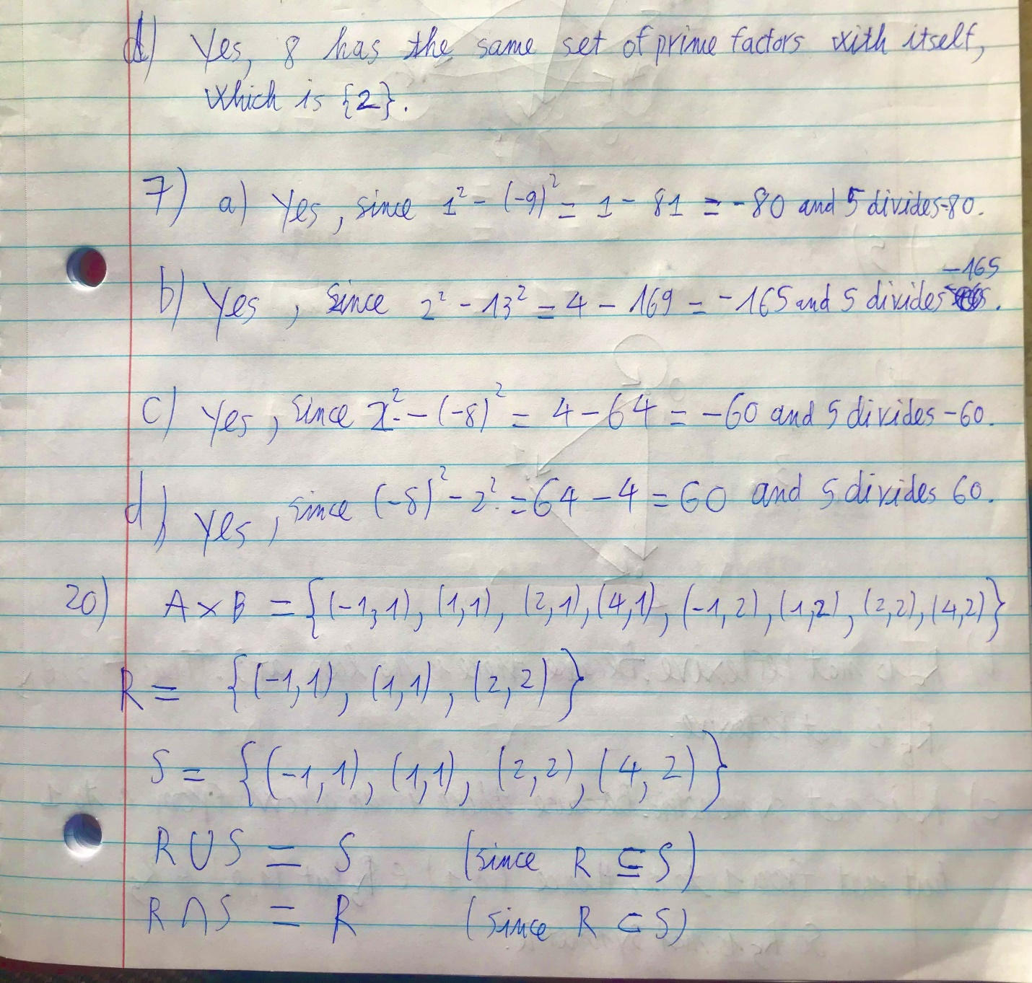

17)

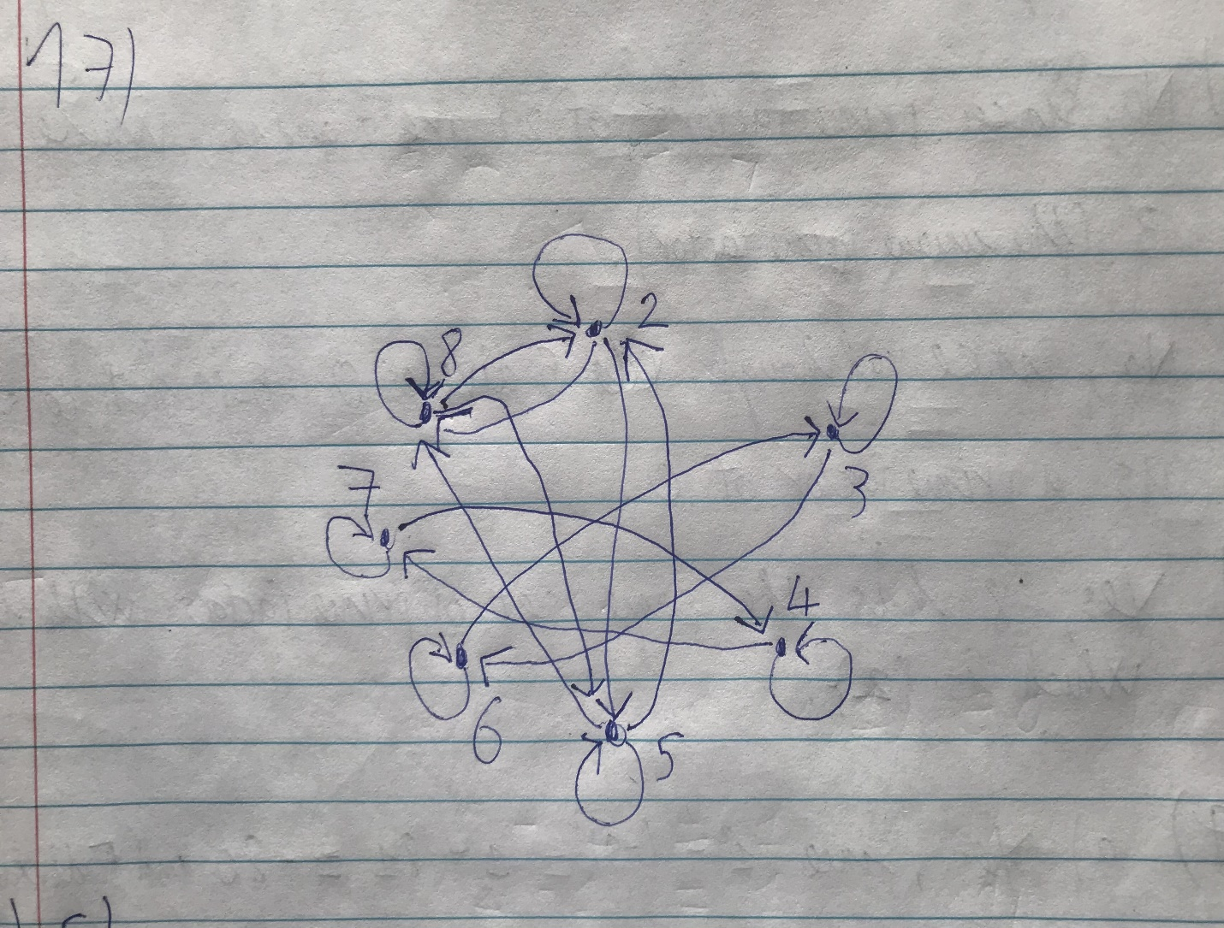

20)

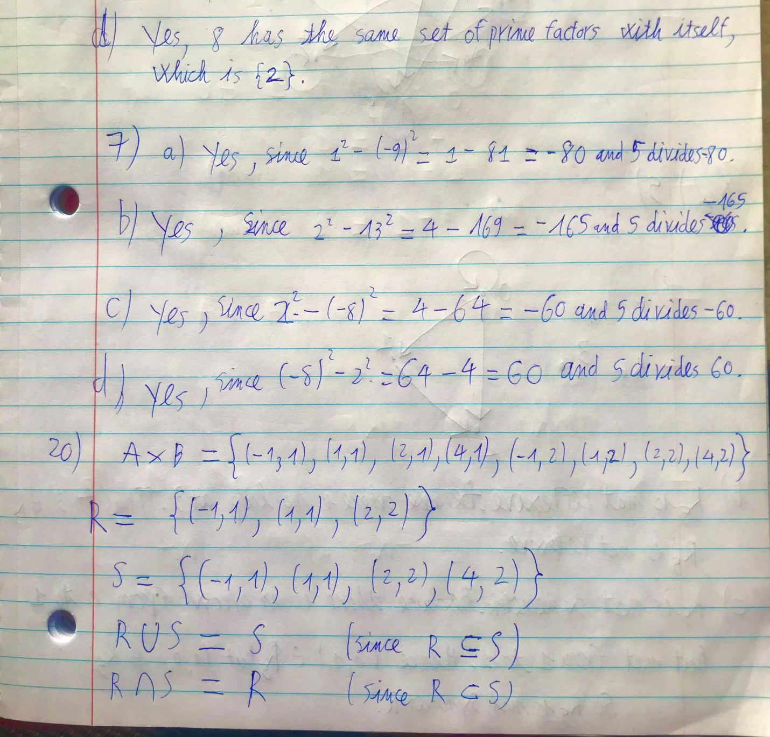

Section 8.2:

5)

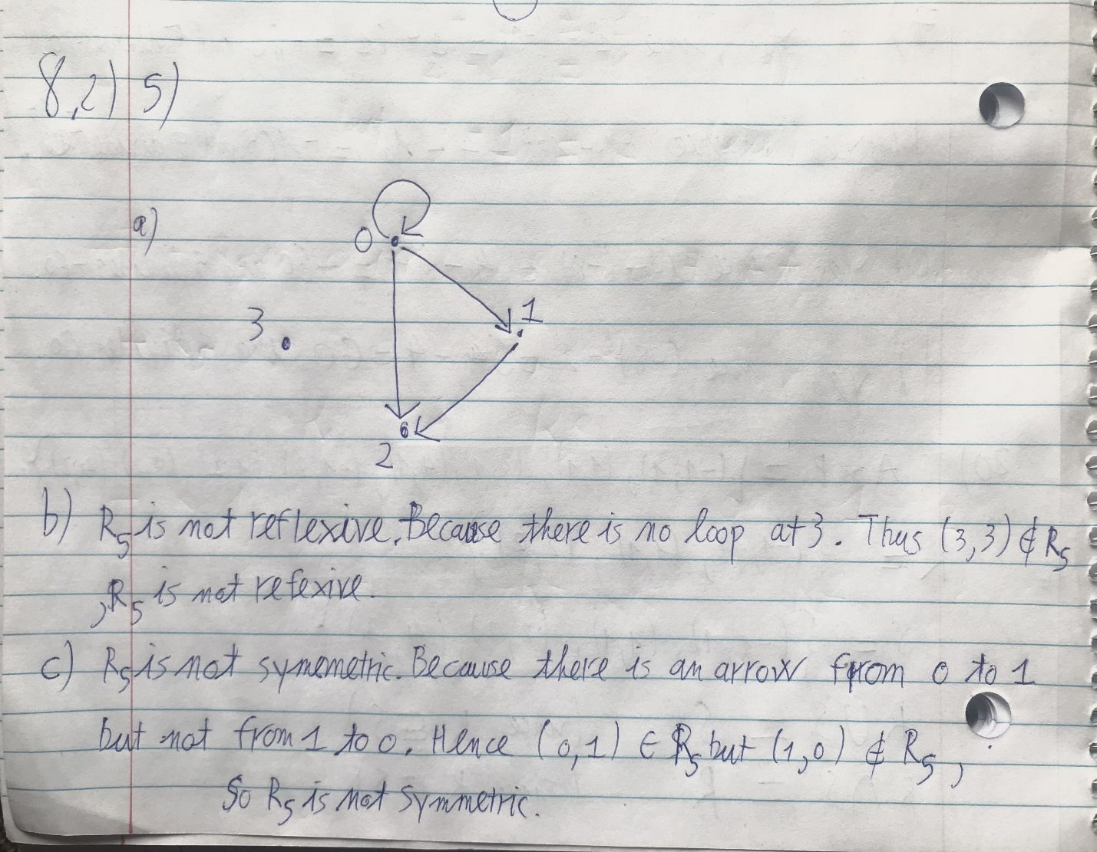

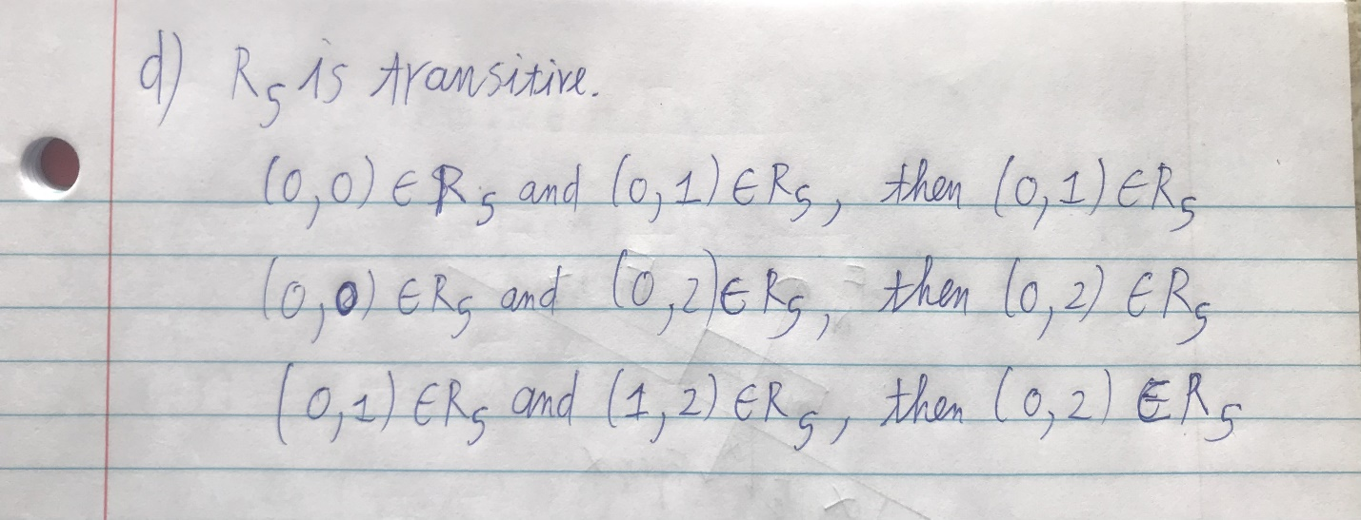

14) 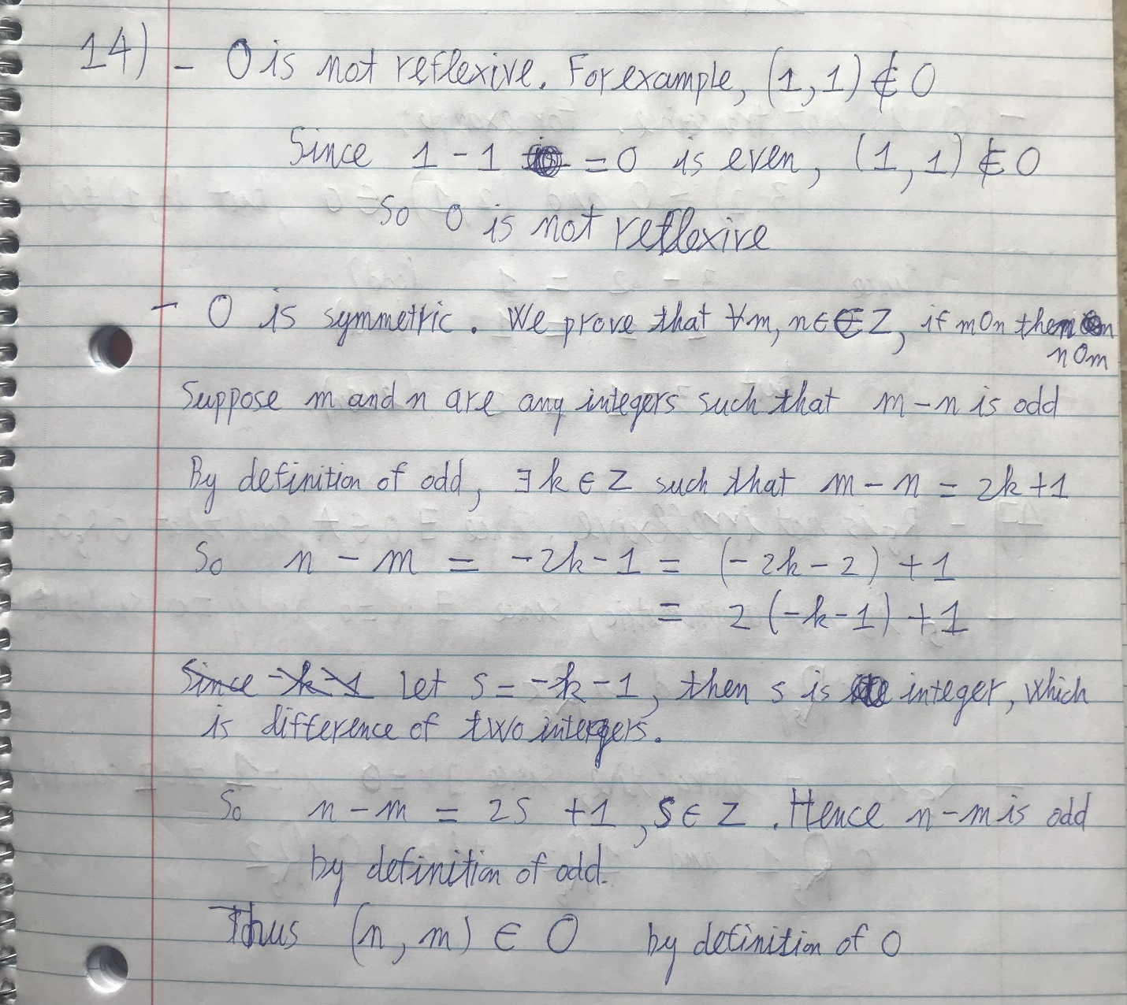

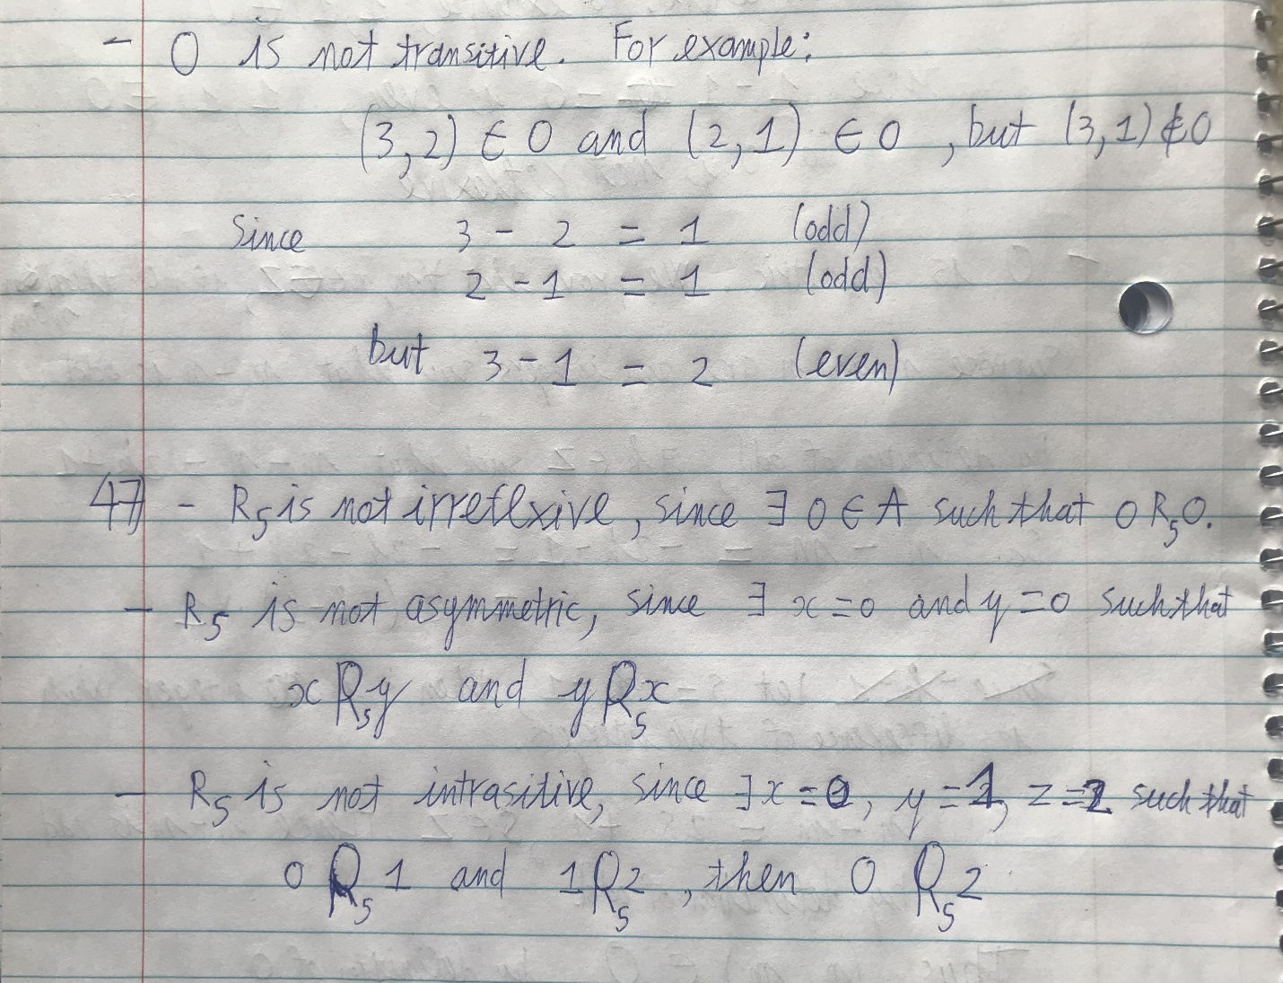

47)



Section 8.3:

12) 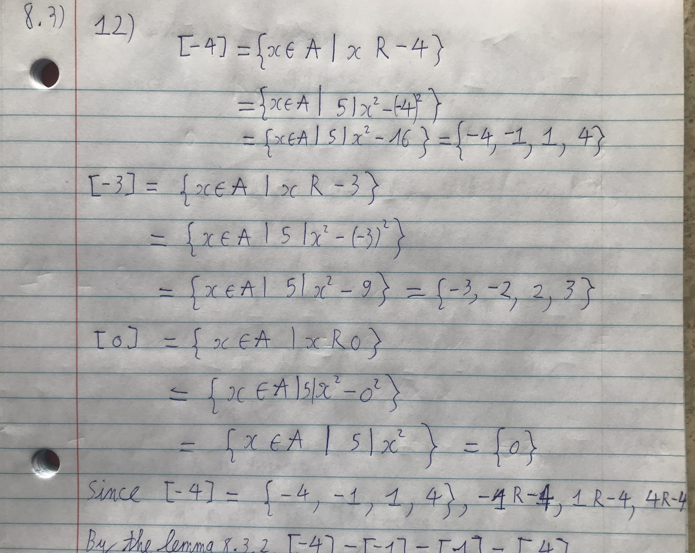

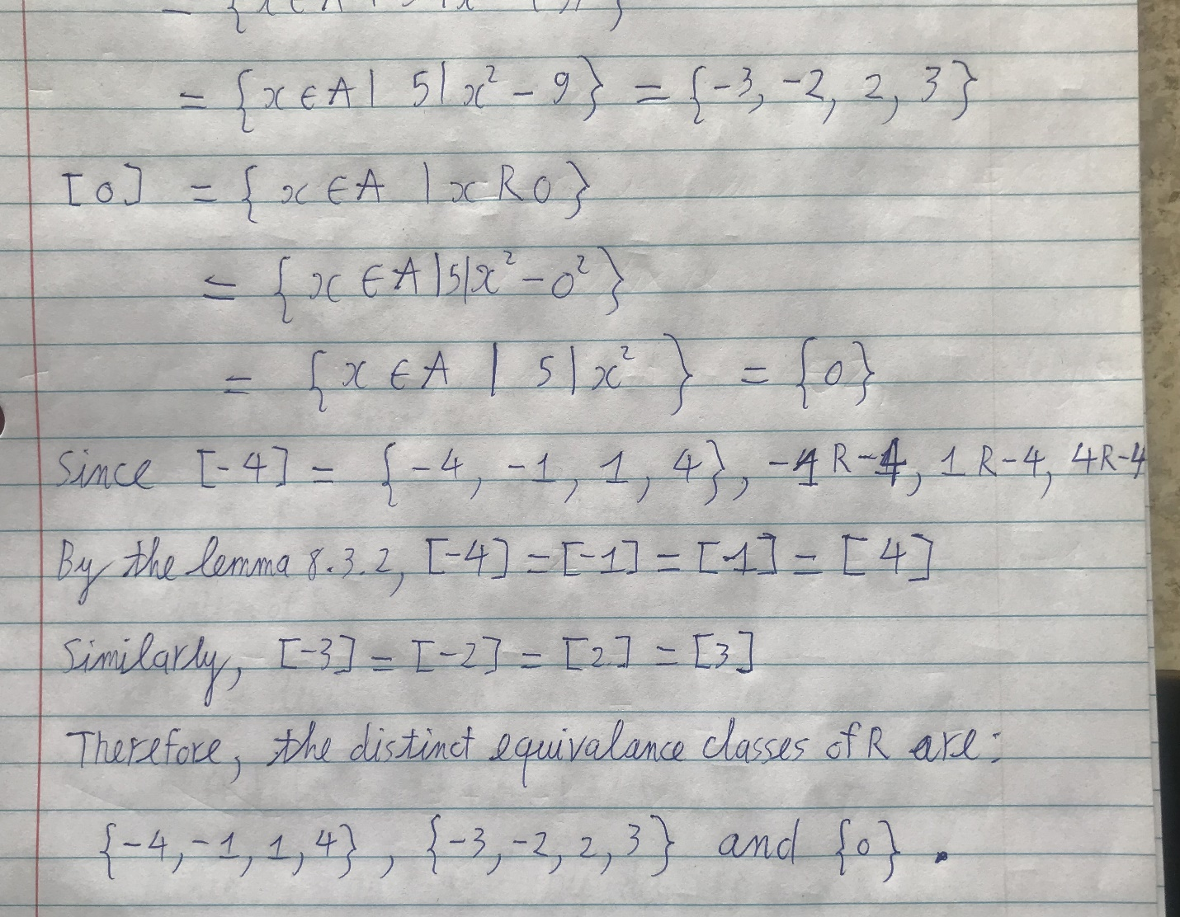

27) 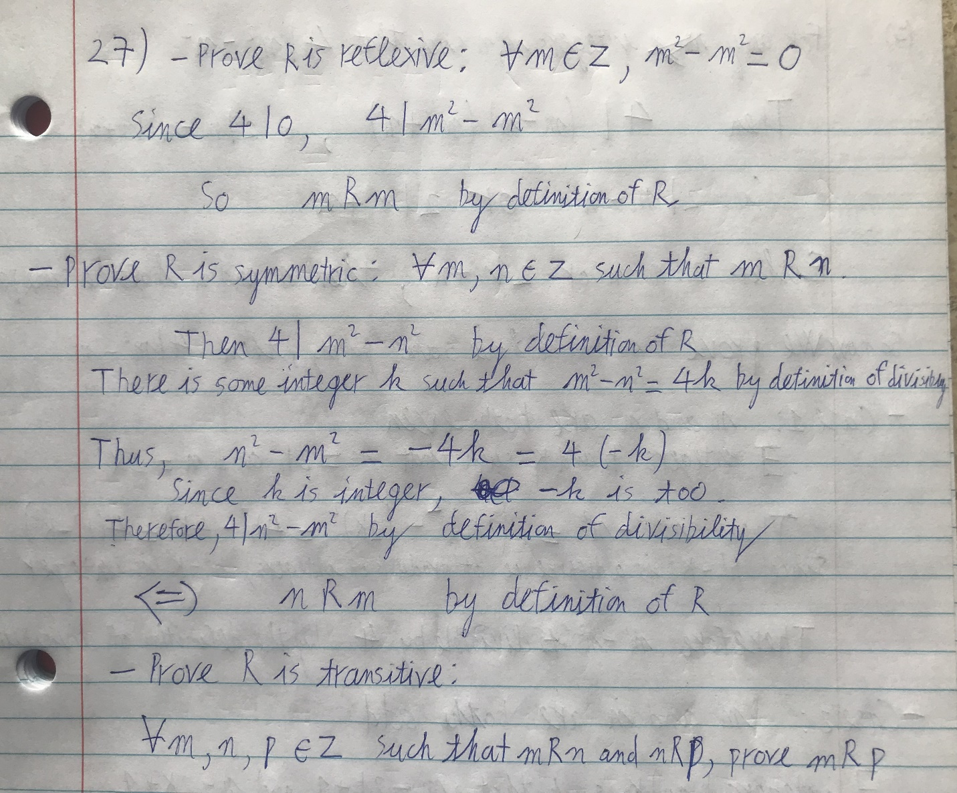

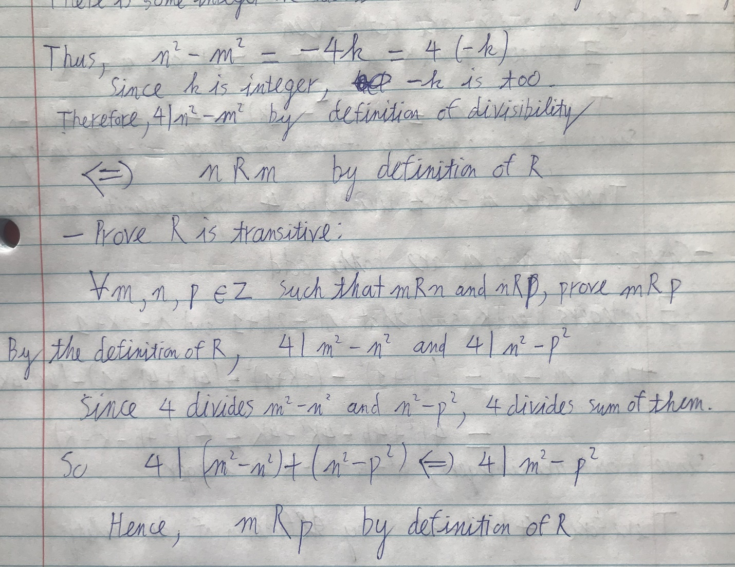

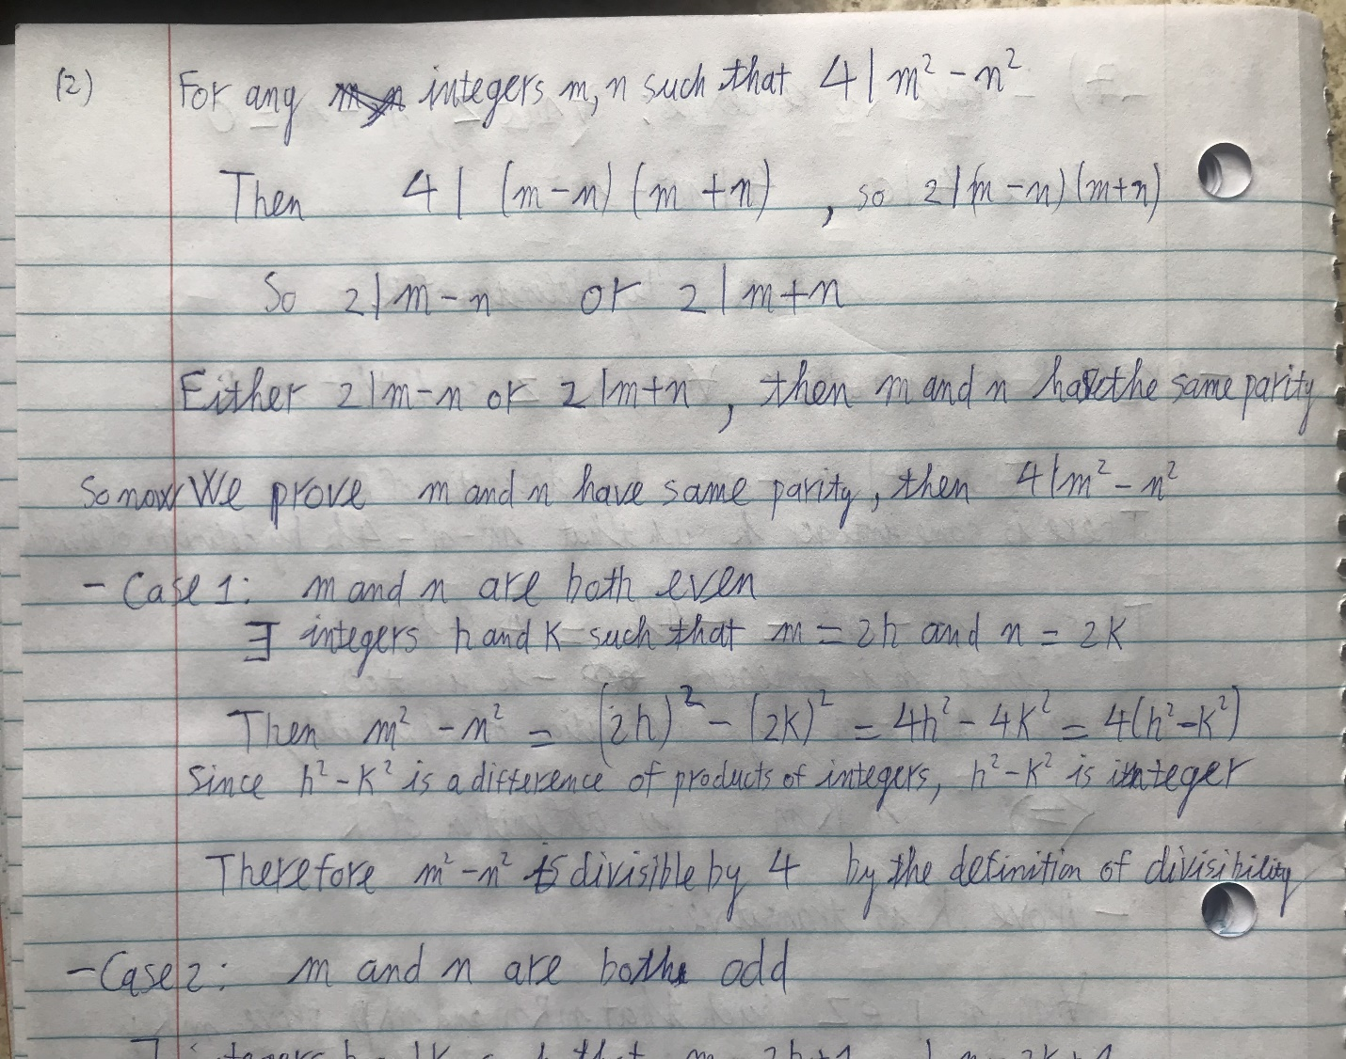

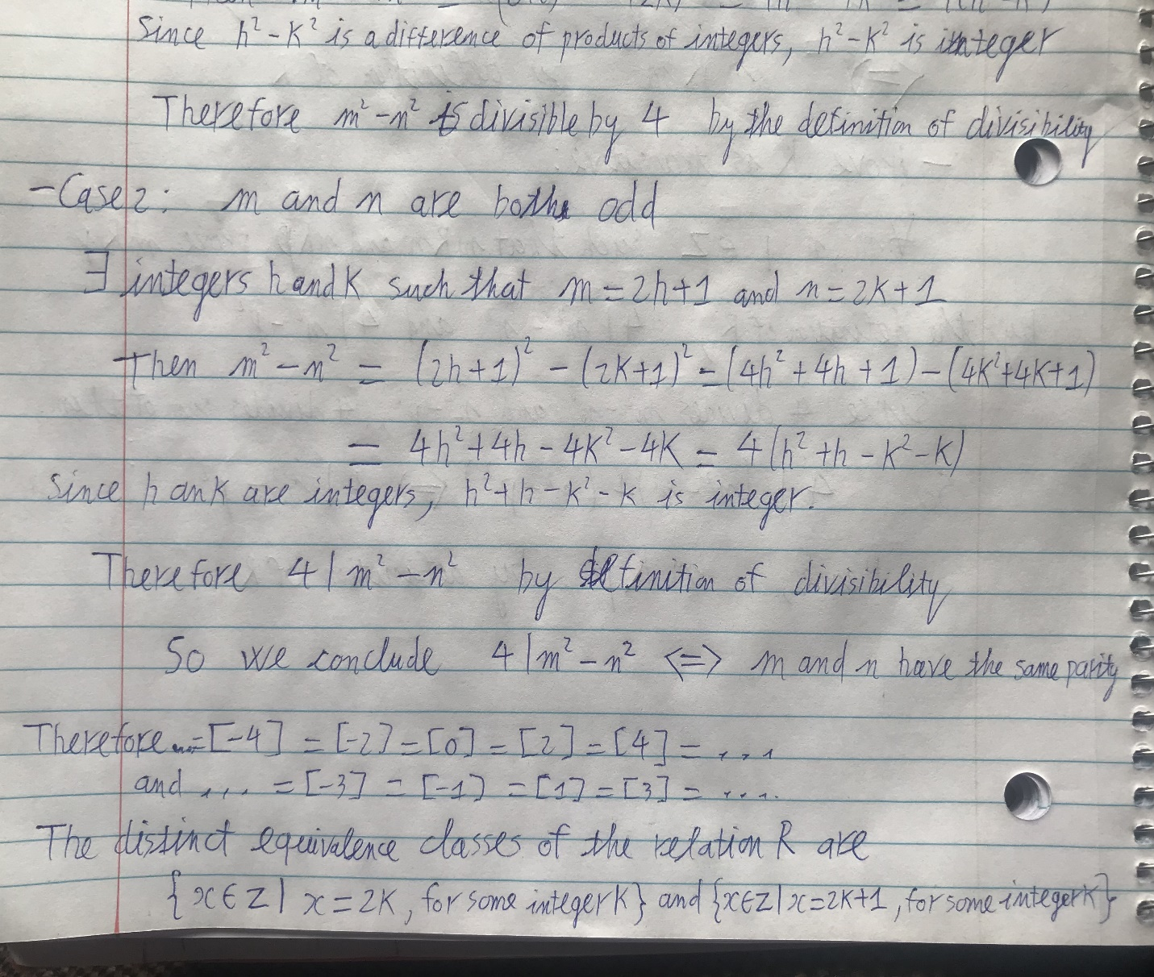

Section 8.5:

6) R is a partial order relation.

- Prove R is reflexive: For any person p, it is obviously p = p.

Then pRp by definition of R.

-Prove R is antisymmetric: For any people m and n such that mRn and nRm,

m is an ancestor of n or m = n, and n is ancestor of m or n = m (by definition of R).

If m is an ancestor of n, then n cannot be ancestor of m and n ≠ m.

This contradicts nRm. Hence, m = n, which satisfies both mRn and nRm, and R is antisymmetric.

-Prove R is transitive: For any people m, n and p such that mRn and nRp, we prove mRp.

mRn, then m is an ancestor of n or m = n.

nRp, then n is an ancestor of p or n = p.

Case 1: m is an ancestor of n, then m is ancestor of p because n is ancestor of p or n = p.

Therefore mRp by definition of R.

Case 2: m = n

Since n is an ancestor of p or n = p, m is an ancestor of p or m = p.

Therefore mRp by definition of R.

So R is always transitive.

Therefore, R is a partial order relation.

7) R is not a partial order relation.

Because R is not antisymmetric.

A counterexample is m = -10 and n = 10.

Then prime factors of m are 2 and 5 and prime factors of n are also 2 and 5.

Thus, every prime factor of m is a prime factor of n, and every prime factor of n is a prime factor of m.

Therefore, mRn and nRm by definition of R.

However m ≠ n, so R is not antisymmetric.